Experiments with polarised light

23142, 07/10/19

# 1. Aim

This experiment aimed to investigate the properties of polarised laser light incident on different optical lenses. By understanding how various polarisations can be produced, the experimental results were compared to the theory.

# 2. Experimental Principles

Light from a laser needed to be polarised in different ways and the intensity of these methods measured. Therefore, an apparatus like that in Fig. 1 was used; with a laser pointed towards a Pasco light sensor set at a gain of 1. A framed polaroid sheet, called the Analyser was placed in between; this frame was able to rotate 360 $°$, with increments of 2 $°$. Firstly, the transmission axis of the laser was obtained by directing the laser through the analyser and then through a prism towards the wall. By tuning the angle of incidence on the prism and tuning the analyser until the light on the wall was at a minimum intensity, the transmission axis, ${β }_{tr}^{'}$, would then be normal angle minus the incident angle. It was obtained that ${β }_{tr}^{'}=47°±1°$, which was used throughout the experiment.

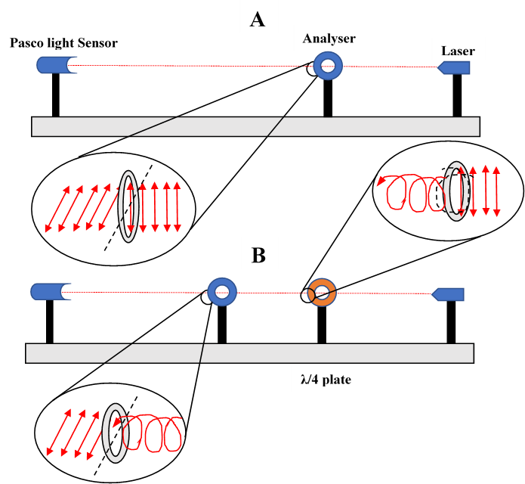 **Fig. 1.** Schematic of the two experimental setups, A and B. Shown with exaggerated magnification of the laser light propagation. (Direction: right to left).

After calibrating, the prism was removed, and the laser was fired directly into the sensor as shown in Fig. 1(a). The light sensor was connected to a multimeter using a BNC cable via an AC adapter; maintaining a maximum reading of 4.000 volts on the multimeter. To investigate linearly polarised light, the frame of the analyser was rotated, and the voltage measured every $15°$ through $0≤β≤360°$ with extra readings taken at points of interest such as minimum/maximum intensity. Background intensity readings were deducted from the measured voltages.

To investigate circularly polarised light; a rotationally adjustable quarter-wave plate, or λ/4 plate was placed in between the analyser and laser like in Fig. 1(b). The same procedure of measuring voltages per incremental degree was followed as in the linear polarisation process. Finally, elliptically polarised light was produced using Fig. 1(b) again. All the procedures led to calculating a degree of polarisation, *P*; for elliptical polarisation, this value would be 0.7. The angle of rotation, δ, for the λ/4 plate was found corresponding to this P value. Then, with δ set, the voltage-angle readings were taken again by rotating the analyser.

# 3. Results and Discussion

To determine the degree of polarisation, *P* [1]*,* was given by,

$P=\frac{I_{max}-I_{min}}{I_{max}+I_{min}}$ (1)

where $I_{max}$ was the maximum intensity and $I_{min}$ was the minimum intensity. To calculate the intensity, the voltage was squared to obtain a relationship like Malus’ Law [2]; given by,

$I\left(β\right)=I_{0}\cos^{2}{β}$. (2)

**a)**

**Fig. 2.** The rotated angle of the analyser plotted against the measured voltage squared (a). The theoretical model appropriated by a $I\left(β\right)=\cos^{2}{β}$ curve (b).

Using equation (1), the degree of polarisation was $P=0.9997±0.0002, 0.9989±0.0012$ and $0.9995±0.002$ for linear, circular and elliptical respectively. From Fig. 2(a), it is clear to see that the linear and circular polarisation curves are like the theoretical sinusoid. The theoretical values for both linear and circular polarisations are 1 as $I_{min}$ would be 0, therefore $\frac{I_{max}}{I_{max}}=1$. This is equivalent to the intensities shown in Fig. 2(b), with equation (2) giving the theory. Therefore, for both linear and elliptical, the error off the theoretical value is $3x{10}^{-4}$% and $1.1x{10}^{-4}$% respectively. In the case of the elliptical polarisation, a P value of 0.7 was desired; the *P* value here isn’t exactly 1 due to the nature of elliptical polarisation. The obtained value is largely off the desired value, being closer to a value of 1. This suggests that the apparatus was set up incorrectly and produced circularly polarised waves instead.

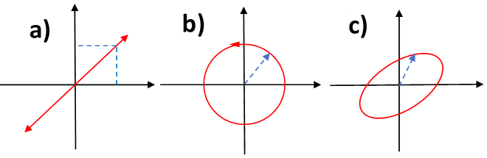

**Fig. 1.** Diagram of the vector components upon polarisation; linear (a), circular (b), elliptical (c).

Regarding the physics in polarisation, the analyser was used as in Fig. 1(a) to transmit incident waves as linearly polarised. With fine gratings on the polaroid sheet, incident waves with vector components in all directions are restricted to only one dimension as in Fig. 3(a) – this is the transmission axis. For circularly polarised light, both the analyser and the λ/4 plate were used, as shown in Fig. 1(b). The analyser again transmits linearly polarised waves and then the λ/4 plate has a circular by-pass for the vector components. If the wave was travelling along the horizontal x plane, it would be observed as a sinusoidal curve from both z and y planes. When viewing into the direction of propagation (x-axis), the path of the wave traces out a circular shape. Therefore, the amplitude of both horizontal and vertical vector components of the wave are equal as shown in Fig. 3(b). Finally, with the elliptical polarisation; the λ/4 plate is off set to the transmission axis. This means that the vertical and horizontal components of the transmitted wave are not equal. Hence, the wave forms an ellipse in the direction of propagation as in Fig. 3(c).

The slight discrepancy in the obtained values was due to systematic fine-tuning in the apparatus. Such as, the rotation of the analyser being accurate to only 2 $°$; this resulted in less accurate changes in the angles. More discrepancies could have been due to difficulty with the instruments used; initially, the laser and sensor were both swapped as the voltage measurements were relatively very small. The required maximum voltage range was 1-2 volts, whereas around 4 volts was obtained even when new sensors were placed. This was not an issue for the sensor as the maximum voltage it can measure before overloading is ~4.5volts. Though, this suggests there could have still been issues with the subsequent measurements. Particularly with elliptical polarisation, a phase shift had to be added to the λ/4 plate to change the amplitude of the vectors. This required finding a minimum intensity point of the laser on a wall, which was purely subjective and dependant on good visual sight and ideal darkness. Taking more measurements at local maxima would have also helped to improve the general smoothness of the curve and obtain more definitive *P* values.

# 4. Conclusions

It has been demonstrated how light can be polarised and the properties of the different types investigated. The degree of polarisation was found for each type; $P=0.9997±0.0002, 0.9989±0.0012$ and $0.9995±0.002$ for linear, circular and elliptical respectively. With linear and circular agreeing closely to the theory of $P=1$, whereas elliptical being considerably off the desired $P=0.7$. This has shown the importance of setting up an experimental apparatus with care.

References

[1] T.J. Badcock *et al.* Characterising the degree of polarisation…(2010).

[2] J. Strong. Concepts of Classical Optics, (2012).